# ASP.NET Web Forms Internals: Requests, ViewState & Page Lifecycle

Most developers are familiar with the high level abstractions that ASP.NET provides for them, such as Web Forms and Web Services. However, below these abstractions sits a very interesting architecture. Knowing the under works of this architecture not only elevates the ASP.NET developer into the advanced zone, but also helps him or her, write better designed applications and solve advanced problems that occur way below the high level ASP.NET use

by [Mohamad Halabi](http://www.pluralsight.com/author/mohamad-halabi)

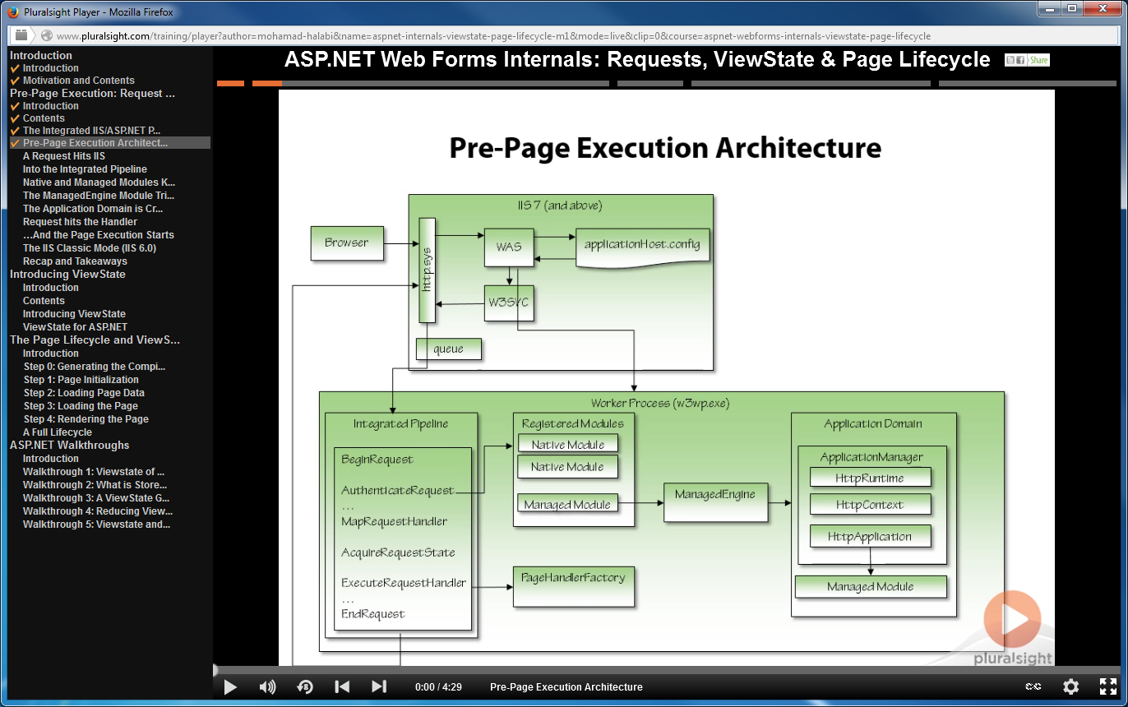

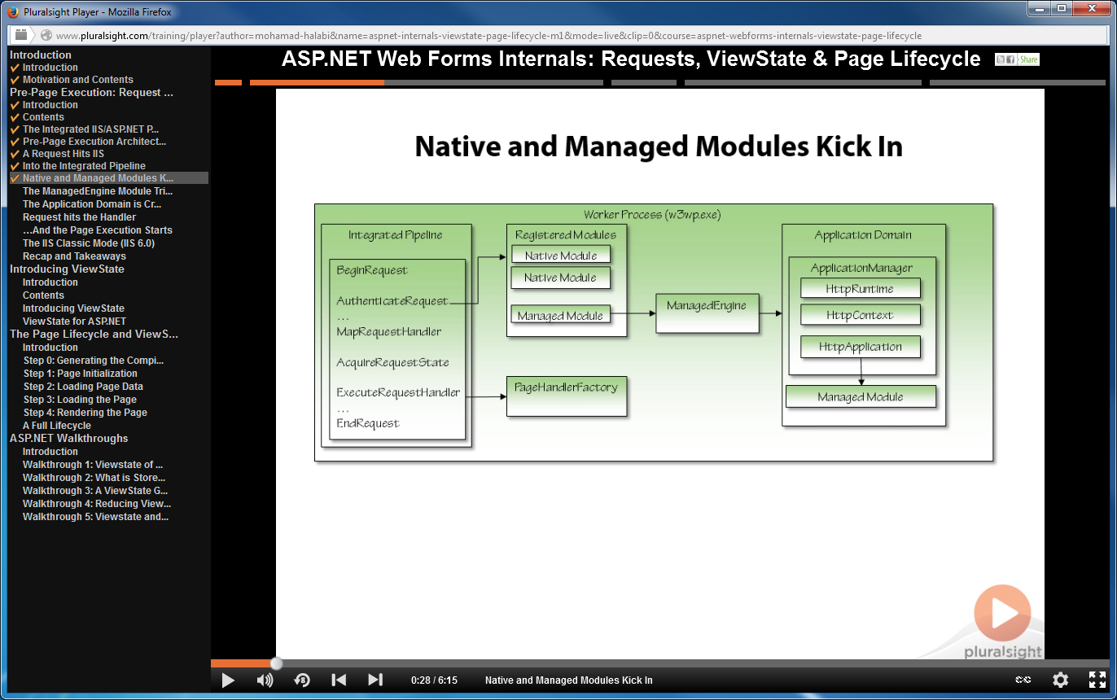

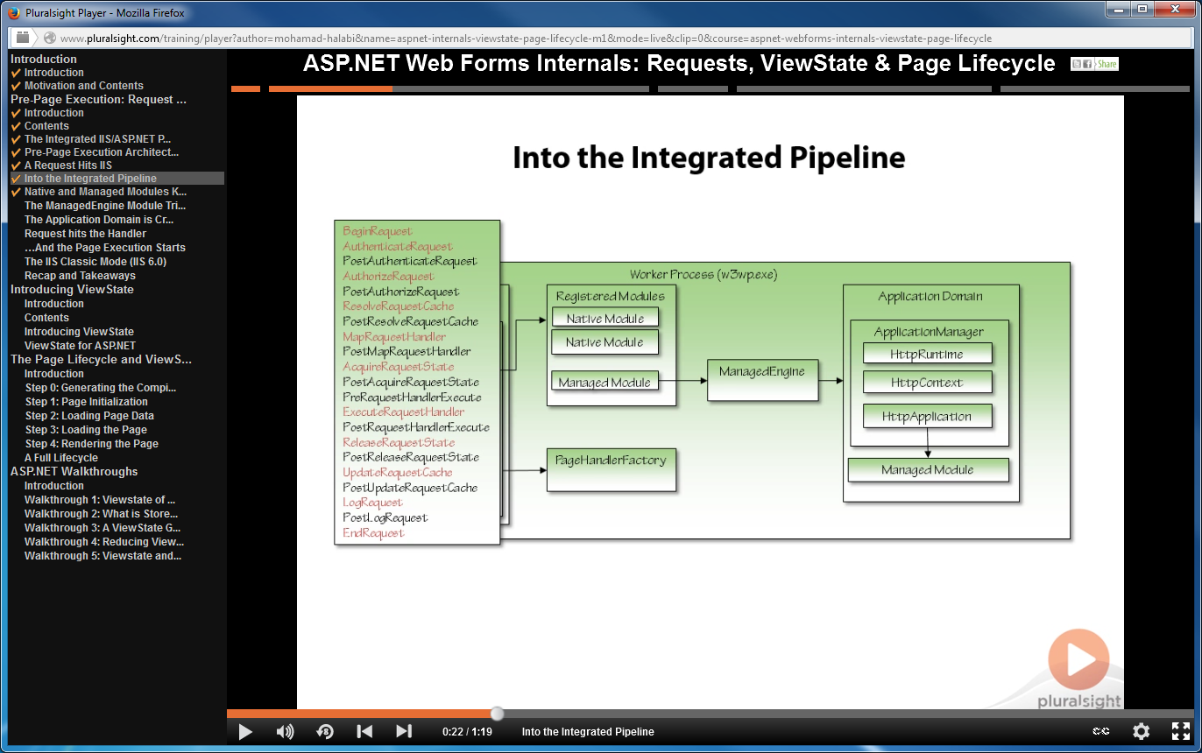

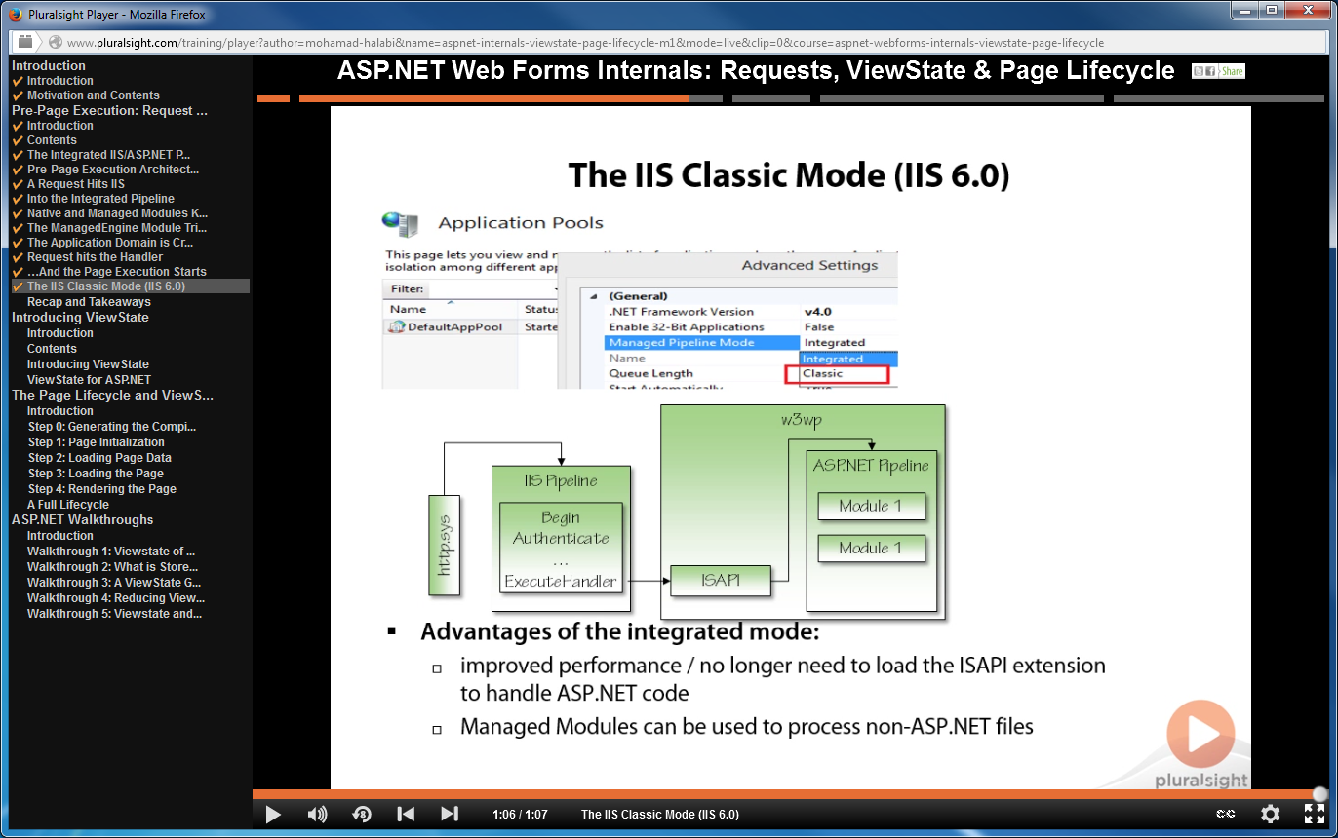

**ASP.NET 3.5 Security**

Learn how to secure your ASP.NET Web applications.

by [Keith Sparkjoy](http://www.pluralsight.com/author/keith-brown)

